Word Template for an ISRM 2015 Paper
S. Zeghloul¹ and I.-M. Chen²
¹ Dept. of GMSC, Pprime Institute, CNRS - University of Poitiers - ENSMA - UPR 3346, France, e-mail: said.zegloul@univ-poitiers.fr
² School of Mechanical and Aerospace Engineering, Nanyang Technological University, Singapore, e-mail: michen@ntu.edu.sg

Abstract. The aim of the 4TH IFTOMM INTERNATIONAL SYMPOSIUM ON ROBOTICS & MECHATRONICS is to bring together researchers, industrials and students involved in a broad range of disciplines related to Robotics and Mechatronics, in an intimate and stimulating environment in order to disseminate their results and to exchange about future works, trends and challenges. The guidelines for authors to create their manuscript in Word are explained in this template. The conference will be the fourth one within this series started in 2009. The abstract must not go over into the second page. The purpose of the abstract is to indicate the subject of the paper, the guidelines proposed by the authors to develop this subject and its overall objective, aim or outcome.
Key words: Please indicate four to five keywords, which will also be used for composing the Subject Index (written in 8 pt, justified).
1 Introduction
First page of the manuscript will include at least the title of the paper, name of authors, their affiliation and email addresses, abstract and keywords. The paper should also contain an abstract, an introduction, the main text, conclusions and references.
The manuscript should be written within 8 pages. A manuscript of less pages may or may not be accepted, depending on the opinions of the reviewers and editors. A manuscript of more than 8 pages will not be accepted.
Each submission will be rigorously reviewed. Accepted papers will be published in a Proceedings book by Springer.
Author names are written in 10 pt, alignment left. Use author style for automatic formatting. Affiliation of authors is written in 10 pt, Alignment left. Use Affiliation style. Abstract is written in 8 pt, justified. Use abstract style.
The title of the paper should be written in 16 pt bold, Alignment left. Use title style. Section titles are 14 pt bold, alignment left and are subtitle style. Subsection titles are 14 pt bold italic, alignment left and subsubtitle style. The following standard numbering is prescribed: 2, 2.1, 2.2 etc. Instead of simply listing headings of different levels we recommend to let every heading be followed by at least a short passage of text.
The following are some examples of a typical equation, figure, table, citations and references. Please do not change the proposed formatting by introducing other styles or by changing this template.
1.1 Paragraphs and indents
Please note that the first line of text that follows a heading is not indented (first line style), whereas the first lines of all subsequent paragraphs are (normal style). The text is 10 pt, justified. Spacing of the text is 12 pt.
2 Figures
Figures should be centered and referenced in the text as, for example, Fig. 1. The font size in figures should be as normal text (10 pt). Captions are placed under the figure, written in 8.5 pt, using figlegend style. The example follows.
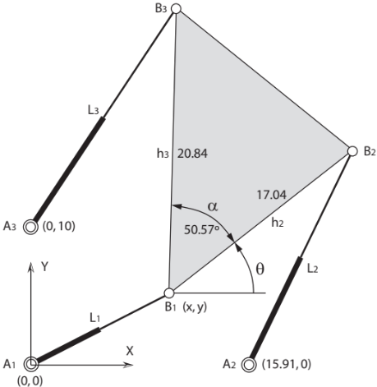
Fig. 1 Please write your figure caption here
3 Equations
The same style as normal text should be used in equation. Here, however Single space is recommended. Equations should be centered and numbered (equation style). They should be referenced in the text as, for instance, Eq. (1). An example of equation is as follows
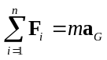 (1)
4 Tables
Tables should be centered and referenced in the text as Table 1. The font size in tables should be table style (8.5 pt). Captions are placed before the table and are centered (tablelegend style).
Table 1. Please write your table caption here
Description 1 | Description 2 | Description 3 | Description 4
Row 1, Col 1 | Row 1, Col 2 | Row 1, Col 3 | Row 1, Col 4
Row 2, Col 1 | Row 2, Col 2 | Row 2, Col 3 | Row 2, Col 4
Row 3, Col 1 | Row 3, Col 2 | Row 3, Col 3 | Row 3, Col 4
5 Referencing
The reference list should be written in an alphabetical order. A citation in the paper should have the form [1, 3, 2, 4] for a contribution in conference proceedings, journal article, monograph and on line document. Use references style (8.5 pt).
6 Conclusions
Your manuscript must be sent following the instructions and deadlines given in the ISRM 2015 web page http://isrm2015.sciencesconf.org/.
Acknowledgments The ISRM 2015 Local Committee wants to acknowledge the support received from the previous organizers of ISRM events.
References
1. Ceccarelli, M.: The Challenges for Machine and Mechanism Design at the Beginning of the Third Millennium as Viewed from the Past. In: Proceedings of Brazilian Congress on Mechanical Engineering COBEM2001, Uberlandia, Invited Lecture, pp. 132-151 (2001)
2. Merlet, J.-P.: Parallel Robots (Series: Solid Mechanics and Its Applications). Springer (2006)
3. Petuya, V. and Alonso, A. and Pinto, Ch. and Altuzarra, O. and Hernandez, A.: A new general-purpose method to solve the forward position problem in parallel manipulators. Advances Robotics, 22, 395–409 (2008)
4. Viadero, F. et al..: A model of spur gears supported by ball bearings. In: Computational Methods and Experimental Measurements XIII (CMEM) Invited lecture (2007) Available via WIT eLibrary. http://library.witpress.com/pages/PaperInfo.asp?PaperID=18033

